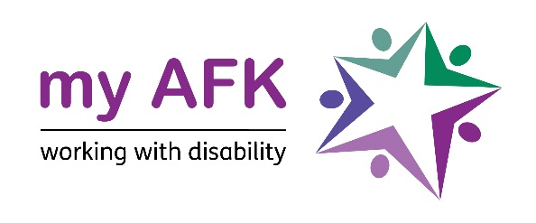
my AFK JOB DESCRIPTION

Job Title: Service Delivery Facilitator

Report To: Services and Business Development Manager

Salary: £25,000 - 27,500 p.a. depending on experience

Location: my AFK Hornsey, London N8 9DJ and other locations as required

DBS: This post is subject to an enhanced criminal record check under the arrangements established by the Disclosure & Barring Service

Context of Job

my AFK is a national charity helping young disabled people develop their independence and find employment. Our vision is a world where all people living with a disability get to lead the life they choose. As part of this we provide bespoke employment skills training and organise work experience across North London. At a national level, we provide mobility equipment not available on the NHS for disabled children and young people up to the age of 25.

Job Purpose

As part of the Service Delivery Team you will deliver work related sessions and activities for disabled young people. This work will take place at our office and at a range of community and employer partners such as Bikes for Good Causes and the Edible Garden.You will also be required to work virtually on some projects with young people and partners. Working with the Services and Business Development Manager, this post will help to deliver new projects and services with a range of organisations, including employers, schools and other voluntary organisations. During the school holidays they will work with the team to deliver a Short Breaks/Holiday Programme both in our office and in the community

Working Conditions

This post is 35 hours per week. The post holder will occasionally be expected to work some evenings and weekends as required by the job

28 days annual leave will be given in addition to all UK recognised public holidays.

My AFK operates a No Smoking policy.

There is a TOIL Policy.

Principal Responsibilities

- Facilitate small group employment and independent life skills sessions for disabled young people.

- Support group activities and individual placements in community and employer partners, such as the Edible Garden and Bikes for Good Causes.

- Work closely with young people, families, and other stakeholders, to help design and develop new activities and projects for young people.

- Promote person centred working and co-production in the planning and designing of activities.

- Help create and administer a range of assessments to show young people’s progress.

- Co-ordinate and co-facilitate support sessions on our Short Breaks/Holiday Programmes.

- Contribute to the monitoring, recording, and reporting of all our programmes and activities.

- Assist with personal care support for students when required.

- Undertake any other duties as required by the Services and Business Development Manager and the Senior Management Team.

Person Specification: Service Delivery Facilitator

Criteria |  | Essential | Desirable
Qualifications | - Professional level qualification in relevant area eg teaching, social work, youth work etc that involves direct involvement with young people
Skills, Experience and Knowledge | - Minimum 18 months experience of working with young disabled people
 | - Knowledge and understanding of current legislation affecting disabled young people and their families
 | - Experienced in developing and running sessions and activities for disabled young people
 | - Experienced in using monitoring, recording and information systems
 | - Understanding of the principles and practice of a person-centred approach
 | - Ability to communicate effectively with young people with communication support needs
 | - Able to motivate young people in a learning environment
Qualities | - Effective time management skills and the ability to prioritise work
 | - Able to use initiative and problem solve
 | - Effective communicator in a range of settings with a range of professionals and others
 | - Adaptable and able to work under pressure
Equal Opportunities | - Commitment to equal opportunities and anti-discriminatory practice
Safeguarding | - Knowledge and understanding of Safeguarding and what it means when working with disabled young people
my AFK’s Aims and Objectives | - Understanding of and commitment to the Mission and Vision of my AFK

