Executive Director of Services

Job Pack

About my AFK

my AFK helps disabled children and young people to live independent and fulfilling lives.

There are two main themes to our work: employment and mobility. We help disabled young people aged 18-25 to develop important life and work skills so they can live more independently and move into paid employment. We also offer a range of face to face and on-line activities for young people aged 14-18 during the school holidays. On the mobility side we provide specialist mobility equipment not available on the NHS to disabled children and young people up to their 25th birthday, across the UK.

This is an exciting time to be joining my AFK. Following a period of rationalisation, a new CEO, David Coe, joined the Charity in March and since then we have embarked on a strategic review. There are 14 million disabled people in the UK and we know disabled people suffer unemployment disproportionately and following a year that ended with lockdown and the threat of a Covid-induced recession, our work will be more vital than ever. One positive aspect of the Covid pandemic has been the successful provision of our employment service digitally and this presents a great opportunity for future development. The broad thrust of our new direction is to expand our services. In particular our employment service is currently London-centric and our ambition is to expand this nationally.

We expect to have completed the strategy and set the milestones by mid-July so the job will focus on undertaking feasibility studies and implementing these new services. The most promising opportunities identified at the time of writing are:

- Expanding our employment service to extend its reach by:
-implementing virtual coaching
-and /or opening up a pilot office in another location
- Not seeing a job in an office as the only end point and expanding our service to include coaching to become self-employed
- Developing a support service for disabled people working from home
- Setting up an ‘incubator hub’ for the self-employed which can be combined with the support service above
- Raising more money to fund more mobility equipment and covering the costs of maintenance which is currently paid for by my AFK

Role Summary
The Director of Services role will lead and give strategic direction to the Services department and take responsibility for the delivery of our services to beneficiaries, their families and our partners, with the overarching aim of delivering tangible change, expansion and improvements in our employment and mobility services. This role will lead cross-team programmes to support the long-term development of the organisation; with a particular focus on leading the organisation's work on diversity and inclusion to improve our reach, and on reporting of impact. In particular, the postholder will drive the provision of new services, by conducting feasibility studies and developing pilot projects and further review the current services.
We are looking for an exceptional candidate whose experience includes:
- A strong track record of developing and delivering high quality services, including:
- Experience of developing services to reach new and diverse audiences.
- Use of digital channels to deliver services.
Undertaking feasibility studies for new services
- change management within existing services
- Excellent knowledge and experience of monitoring, evaluation and data collection, and using this to measure and report impact as well as to inform and develop services to meet identified needs.
- Significant experience of project planning, feasibility studies, management and reporting, with proven ability to work with funders to meet reporting needs.
- Excellent written and verbal communication skills, including proven experience of external representation with and presentations to high level professional audiences.
- Knowledge and understanding of current best practice in the design and delivery of education and training for young people with SEND and/or ASD
- Experience, knowledge and understanding of transition processes for young people with learning disabilities
- Understanding of transition issues for young people and their families
- Knowledge of the barriers facing young people with SEND in finding employment and of supported employment and job coaching
- Experience of working at a senior level and supporting long-term strategic planning and decision-making.
- Experience of leading safeguarding within an organisation
- Extensive management experience with the ability to motivate teams and coach individuals.
- Ambition, a high degree of professionalism and a commitment to achieve outstanding results.
- Ability to build and manage relationships with a range of internal and external contacts, including a board of trustees.

Why work with my AFK?

my AFK has been committed to supporting disabled children and young people for almost 30 years and we need the very best of talents to keep our mission alive. We are a team of passionate individuals who are 100% committed to make a difference to disabled young people’s lives and see the charity grow. We take pride in our inclusive work culture and encourage team members to bring their whole self to work.
Our focus is on a young person’s potential and aspirations, not the apparent barriers they face. This is part of the social model of disability, which says that disability is caused by negative attitudes and exclusion within society, rather than the individual’s impairment. This is different to the medical model of disability, which simply looks at the functions of the body and whether it conforms to what’s seen as ‘normal’.

Here at my AFK we work to address and remove the social barriers that disable people, by providing mobility equipment, education support, skills training and helping young people secure work placements. We believe these services are an essential part of helping young people succeed.

We believe it’s our social and economic structures that stop disabled people from living an engaged and fulfilling life, not the impairment or disability.

This is what we tell our students and trainees: you don’t need to change; society does.

Our values

We are straightforward. We share our experiences, knowledge and understanding about disability, and welcome honest and frank discussion on how to achieve our mission.

We respect & value every individual. We respect you and all our stakeholders. We value every opinion and put disabled people at the centre of what we do.

We are passionate. We were formed by someone who was passionate about ensuring a better future for disabled young people. This passion is still behind everything we do.

We are approachable & supportive. We are an open and outward looking organisation that makes it easy for disabled people and their families to seek help. We build long-term partnerships with those we help.

We are committed. We challenge situations where disabled people do not receive the help, support and understanding they need.

What we offer:

28 days annual leave (in addition to all statutory public holidays), pro rata for part time

Flexible working arrangement (currently piloting Hybrid working with 2 core days in the office and 3 days working from home)

24/7 Employee assistance programme & counselling service

35 hours full time working week

Greater work life balance

Employee retail discounts powered by Reward Gateway Foundation

Flu Vaccine reimbursement

Life assurance scheme for those who work over 16 hours per week

Generous Maternity leave pay

Office Closure during Christmas period

Recruitment Timeline
Closing date for applications: Tuesday 6th July 2021 9am.
Preliminary interviews with my AFK: 8-15th^{th} July 2021
Panel Interview etc: Week commencing 19th July 2021

The intention is to interview face to face in line with COVID-19 social distancing guidelines and subject to Government Guidance. We would be willing to accommodate virtual interviewing if required.

Mobility Equipment Project

ELIZA

Eliza is a 6-year old girl from Cornwall. She likes going to school and mixing with
her classmates. She adores her family and has a very close bond with her brother
Charlie, as they both have wheelchairs. She also likes to go swimming and goes to
a heated pool once a week for classes.

Eliza suffered a Global Hypoxic Brain injury at the age of 17 months. She was taken
to Bristol Children’s Hospital and placed in an induced coma on life support. Her
family were advised to say goodbye to her, but when she was taken off life support,
she fought to get better. While in the hospital she lost her sight, hearing and was
having seizures. Over time she regained these, but as she’s grown she has had
increased difficultly with her mobility. She uses hinged splints to help with walking
short distances and uses a wheelchair to get around outside of her home. Her
family say that Eliza ‘simply starts each day the same, happy and full of joy and
love. She is an inspiration.’
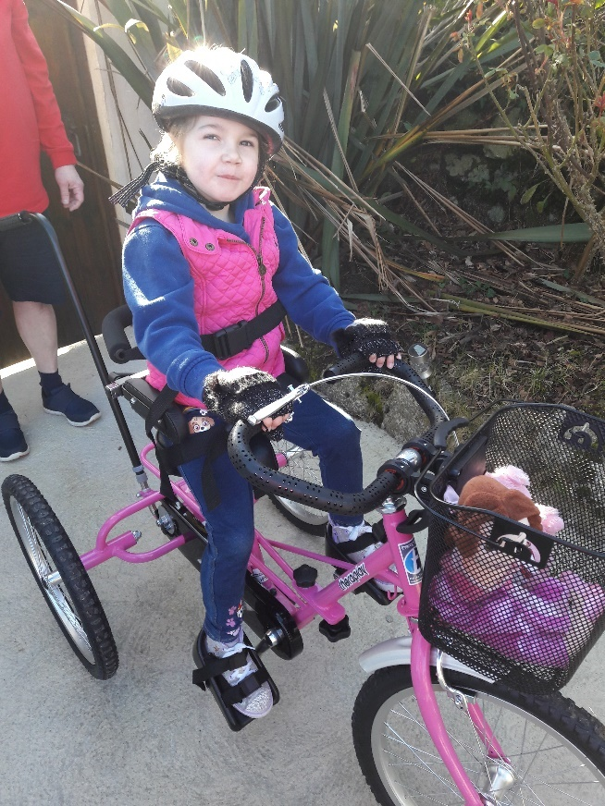
Her family applied to my AFK for funding for
a specialist trike after Eliza’s
physiotherapist suggested the significant
physical, neurological, and psychological
benefits of having an adapted trike. When
she had her assessment, Eliza beamed and
loved the feeling of pedalling. Having a new
trike allowed her to join in on bike rides with
her friends and family, giving her a sense of
freedom and inclusion while building her
confidence and muscles.

When her trike was delivered her father got
in touch to say, “We just wanted to say
thank you and all the team at AFK for
helping Eliza achieve a dream. Her new trike
is absolutely fantastic and we have enjoyed
several bike rides as a family. Eliza has been
so happy on her new wheels. Several ‘cuddlies’ have been selected for the rides so far!!

A GREAT BIG THANK YOU from all of us to you and AFK.”

Life & Work Project

RUBEN

‘To find a job you like is not easy for anyone. It may take longer than a week or a month but if you keep trying and don’t give up and with help from places like AFK, even in this pandemic, you will have a chance’

Ruben is on the autistic spectrum and has a mild learning disability. He came to AFK after his Aunty referred him to the Life & Work team. Having worked as a cleaner for a few years Ruben was ready for his next step. After help from the team in improving his resume and setting out his goals, he was ready to start honing his interview technique, approaching employers and bolstering his skillset.

The team organised to record Ruben’s sessions, answering questions and then listening back to how he articulated himself. This enabled him to hear himself back and make improvements such as slowing down with his speech and taking his time in explaining different aspects of his experience and how these would help him in the role. Whilst he had successfully progressed to the second interview on a couple of occasions, he had not yet been in successful in securing a new position.

A noticeable change in Ruben’s approach to the process was when he completed three separate interviews with three different corporate partners that support AFK. Taking onboard the advice and support given to him, Ruben was displaying a new air of confidence, coming back stronger and stronger for each session. During this time he passed his driving test and moved to his own flat independently. He was gaining traction in his search for a new role, however, Covid-19 put the breaks on this progress.

The first lockdown in March 2020 triggered an 8-month stint of furlough from the Southbank Centre for Ruben. Although grateful to receive government support - meaning he was just about able to maintain his independence – fears over imminent job losses meant he was in danger of losing his new home.

Unfortunately, like many in Ruben’s position, these fears were realised, as he was let go in the autumn due to wave of redundancies.

Not to be disheartened, Ruben had applied for a number of retail roles, yet he found the application process challenging due to the number of online tests before even being considered for an interview.

Continues over page

‘Ruben has displayed great staying power, despite feeling disappointed at not getting through, each time he would pick himself up and start working with AFK once more to apply for the next job role.’ explains Ruben’s Job Coach.
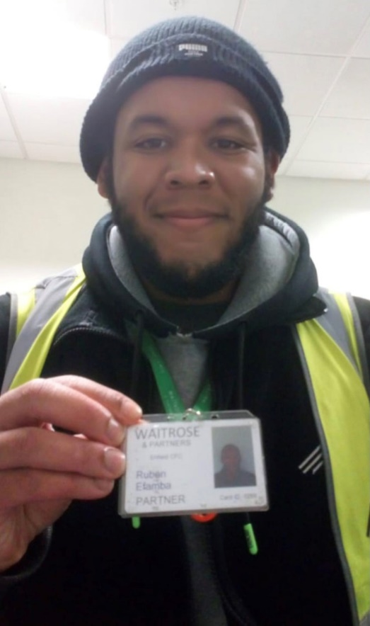
With rent payments looming and no foreseeable pay cheque, AFK helped Ruben with an application to ‘Aid for Asperger’s’, a small charity that helps and support young adults who have Asperger’s Syndrome to improve the condition of their lives. They very generously donated £500 – a large donation for a charity of their size - to cover rent and food as he awaited news of work, for which Ruben is so grateful.

Before long, Ruben had made a successful application to a major supermarket.

‘It all happened in quite a hurry’ he said. Reasonable adjustments were negotiated, meaning Ruben went straight through to an interview and he could concentrate on application details.

‘Ruben mastered the art of making a good impression at an interview.’

This was clearly the case, as within a week of being told of his redundancy, he had been offered a new position working in a supermarket warehouse. Now 24, Ruben’s hopes of changing his career path have come to fruition.

‘My confidence has grown significantly, and it has given me more knowledge in regards to what the job market is all about’ he exclaims.

