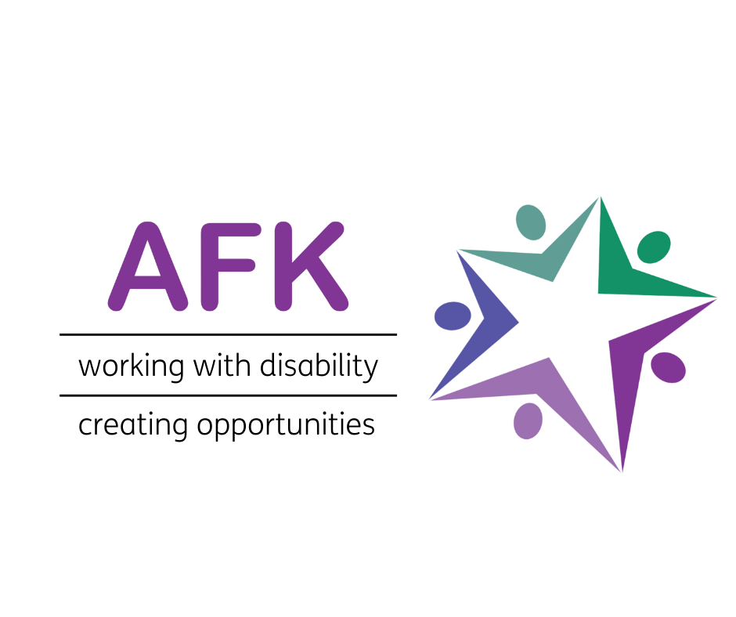

**Chair and Board Members**

**Job Pack**

**May 2022**

**Index**

1. About AFK
2. Summary of Role and Skills Sought
3. Introduction from Chair
4. Message from Chief Executive
5. Why Work With AFK?
6. Beneficiary Case Studies

Appendix 1 Chair Job Description and Person Spec

Appendix 2 Treasurer Description and Person Spec

Appendix 3 Trustee Role Description

Appendix 4 Application and Appointment Process

Appendix 5 What the Role Will Entail

1. **About AFK**

**Our vision is a world where all disabled young people get to lead the life they choose  
  
Our mission is to give as many young people with disabilities or autism the opportunity to lead fulfilling lives**

AFK supports disabled children and young people to live independent and fulfilling lives.

There are two main themes to our work: employment and mobility. We help disabled and autistic young people aged 18-25 to develop important life and work skills so they can live more independently and move into paid employment or self-employment. On the mobility side we provide specialist mobility equipment not available on the NHS to disabled children and young people up to their 25th birthday, across the UK.

This is an exciting time to be joining AFK as we have recently completed a strategic review across our services and fundraising portfolio. There are 14 million disabled people in the UK and we know disabled people suffer unemployment disproportionately. As we come out of the pandemic our work is more vital than ever to ensure that disabled and autistic young people have the support they need to live a fulfilling life

1. **Summary of the Role**

Trustees play a crucial role in setting and supporting AFK’s strategy. Most of our Trustees have served on the Board for a long time - increased due to pandemic restrictions. We have now instituted Board rotation terms and are looking to recruit nine Trustees including a Chair and Treasurer.

**Specific Skills Sought**

* Finance
* Project Management
* Business acumen
* Project Management
* Extensive Networks
* PR and Comms
* Strategic planning
* Disability and autism (also through Lived Experience)
* Skills training and employment
* Policy
* Safeguarding

Previous Board/Trustee experience is not necessary and we welcome applications from all ages and backgrounds. These positions could therefore suit individuals taking their first steps to develop wider Board level and governance experience. If you don’t have these skills but you believe that your background could be useful to us and you are interested in joining our Board, please do still get in touch. We would like to improve the diversity of our Board and therefore would particularly like to hear from women, ethnic minorities, younger people, disabled people, those with autism, neurodiversity, and marginalised groups.

“Trustees have overall control of a charity and are responsible for making sure it’s doing what it was set up to do. They may be known by other titles, such as: directors; Board members; governors; committee members. Whatever they are called, Trustees are the people who lead the charity and decide how it is run.” (The Charity Commission)

1. **Introduction from Chair**

“Being a Trustee at AFK is wonderful because you will be making the World a better place one person at a time. At AFK we help disadvantaged young people with moderate to severe learning difficulties to live more independently and to reach their full potential, including permanent or part-time employment.”

Thank you for your interest in becoming a Trustee or Chair at AFK. It is an inspirational and enterprising Charity having grown and expanded from the original site in North London and from providing mobility equipment for young people. This Charity changes people’s lives and has now been running for 30 years. Being a Trustee is a rewarding, interesting and challenging role. As a Trustee you play an important part in the development of the Charity working with the Chief Executive and management team to deliver high quality and innovative services and projects to people across the UK. As a Trustee I find the role both interesting and rewarding and have very much enjoyed being part of the Charity’s growth. With a range of new developments planned and opportunities available this is a great time to become a Trustee and support the Charity in its further development. We are looking to bring on Board new Trustees with a passion for improving the opportunities for people with a disability or autism to be able to lead fulfilling and rewarding lives.

Mark Lewis

Chair

**4. Message from Chief Executive**

AFK was founded by Mike and Sally Bishop who, 30 years’ ago, identified a need for the provision of specialist mobility equipment not available on the NHS. From this starting point the Charity began its employment service helping people with a disability or autism gain meaningful employment or voluntary positions. I have had the privilege of being Chief Executive for just over a year and in this time we have stabilised the finances and agreed an exciting growth plan and three year financial framework. This financial year will see a small surplus with income projected to grow from a current £1.7m to £2.2m over the next three years. As well as serving more people through our current work we are planning to expand into providing help for our beneficiaries to become self-employed and opening a social enterprise training centre.   
  
One of the great joys of my job is seeing first-hand how we transform lives. Often a student will come to us with little experience of or confidence for life outside the family home. By the time they leave us they will have learnt to be confident, to travel independently and to gain and hold down a job or voluntary position. By expanding into providing self-employment training, we can open up opportunities for people to work in more flexible ways from the support network of their home and families. It is similar on the mobility side: young people’s lives are transformed by the mobility equipment we provide which enables them to participate more fully in family, work and social life.   
  
Our Board has recently moved to fixed Board Terms and many of our existing Trustees have been with the organisation for a long time. Through this renewal and recruitment process we need to identify the talent and passion to guide us through our next years of expansion and we are looking to replace the majority of our Board over the next few months.

At AFK we have an excellent staff team and strong support from volunteers and the local community. Our beneficiaries are fully involved in shaping the projects and services we run through co-production.

I hope you find this information pack useful. Please do not hesitate to get in touch should you have any questions or would like to discuss the opportunities further.

David Coe

CEO

**5. Why work with AFK?**

AFK has been committed to supporting disabled and autistic children and young people for 30 years and we need the very best talent to keep our mission alive. We are a team of passionate individuals who are 100% committed to making a difference to disabled young people’s lives and to seeing the charity grow so we can support more young people. We take pride in our inclusive work culture and encourage team members to bring their whole self to work.

Our focus is on a young person’s potential and aspirations, not the apparent barriers they face. This is part of the social model of disability, which says that disability is caused by negative attitudes and exclusion within society, rather than the individual’s impairment.

Here at AFK we work to address and remove the social barriers that disable people, by providing mobility equipment, education support, skills training and helping young people secure work placements. We believe these services are an essential part of helping young people succeed.

We believe it’s our social and economic structures that stop disabled people from living an engaged and fulfilling life, not the impairment or disability. This is what we tell our students and trainees: you don’t need to change; society does.

**Our values**

We are **straightforward.** We share our experiences, knowledge and understanding about disability, and welcome honest and frank discussion on how to achieve our mission.

We **respect & value every individual**. We respect you and all our stakeholders. We value every opinion and put disabled people at the centre of what we do.

We are **passionate**. We were formed by someone who was passionate about ensuring a better future for disabled young people. This passion is still behind everything we do.

We are **approachable & supportive**. We are an open and outward looking organisation that makes it easy for disabled people and their families to seek help. We build long-term partnerships with those we help.

We are **committed**. We challenge situations where disabled people do not receive the help, support and understanding they need.

**6. Case Studies**

**6.1 Mobility Equipment Project**

**ELIZA**

Eliza is a 6-year-old girl from Cornwall. She likes going to school and mixing with

her classmates. She adores her family and has a very close bond with her brother

Charlie, as they both have wheelchairs. She also likes to go swimming and goes to

a heated pool once a week for classes.

Eliza suffered a Global Hypoxic Brain injury at the age of 17 months. She was taken

to Bristol Children’s Hospital and placed in an induced coma on life support. Her

family were advised to say goodbye to her, but when she was taken off life support,

she fought to get better. While in the hospital she lost her sight, hearing and was

having seizures. Over time she regained these, but as she’s grown she has had

increased difficultly with her mobility. She uses hinged splints to help with walking

short distances and uses a wheelchair to get around outside of her home. Her

family say that Eliza ‘simply starts each day the same, happy and full of joy and

love. She is an inspiration.’

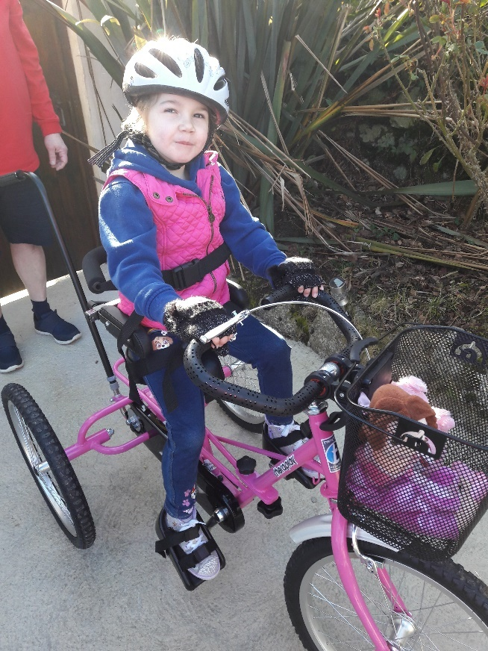

Her family applied to my AFK for funding for

a specialist trike after Eliza’s

physiotherapist suggested the significant

physical, neurological, and psychological

benefits of having an adapted trike. When

she had her assessment, Eliza beamed and

loved the feeling of pedalling. Having a new

trike allowed her to join in on bike rides with

her friends and family, giving her a sense of

freedom and inclusion while building her

confidence and muscles.

When her trike was delivered her father got

in touch to say, “We just wanted to say

thank you and all the team at AFK for

helping Eliza achieve a dream. Her new trike

is absolutely fantastic and we have enjoyed

several bike rides as a family. Eliza has been

so happy on her new wheels. Several ‘cuddlies’ have been selected for the rides so far!!

A GREAT BIG THANK YOU from all of us to you and AFK.”

**6.2 Life & Work Project**

**RUBEN**

‘To find a job you like is not easy for anyone. It may take longer than a week or a month but if you keep trying and don’t give up and with help from places like AFK, even in this pandemic, you will have a chance’

Ruben is on the autistic spectrum and has a mild learning disability. He came to AFK after his Aunty referred him to the Life & Work team. Having worked as a cleaner for a few years Ruben was ready for his next step. After help from the team in improving his resume and setting out his goals, he was ready to start honing his interview technique, approaching employers and bolstering his skillset.

The team organised to record Ruben’s sessions, answering questions and then listening back to how he articulated himself. This enabled him to hear himself back and make improvements such as slowing down with his speech and taking his time in explaining different aspects of his experience and how these would help him in the role. Whilst he had successfully progressed to the second interview on a couple of occasions, he had not yet been in successful in securing a new position.

A noticeable change in Ruben’s approach to the process was when he completed three separate interviews with three different corporate partners that support AFK. Taking onBoard the advice and support given to him, Ruben was displaying a new air of confidence, coming back stronger and stronger for each session. During this time he passed his driving test and moved to his own flat independently. He was gaining traction in his search for a new role, however, Covid-19 put the breaks on this progress.

The first lockdown in March 2020 triggered an 8-month stint of furlough from the Southbank Centre for Ruben. Although grateful to receive government support - meaning he was just about able to maintain his independence – fears over imminent job losses meant he was in danger of losing his new home.

Unfortunately, like many in Ruben’s position, these fears were realised, as he was let go in the autumn due to wave of redundancies.

Not to be disheartened, Ruben had applied for a number of retail roles, yet he found the application process challenging due to the number of online tests before even being considered for an interview.

*Continues over page*

**‘Ruben has displayed great staying power, despite feeling disappointed at not getting through, each time he would pick himself up and start working with AFK once more to apply for the next job role.’** explains Ruben’s Job Coach.

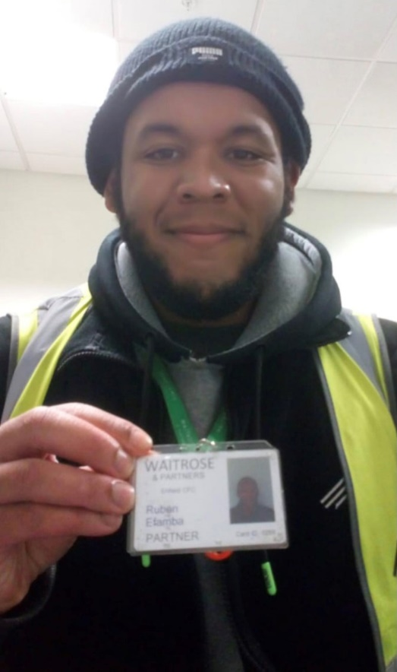

With rent payments looming and no foreseeable pay cheque, AFK helped Ruben with an application to ‘Aid for Asperger’s’, a small charity that helps and support young adults who have Asperger’s Syndrome to improve the condition of their lives. They very generously donated £500 – a large donation for a charity of their size - to cover rent and food as he awaited news of work, for which Ruben is so grateful.

Before long, Ruben had made a successful application to a major supermarket.

‘It all happened in quite a hurry’ he said. Reasonable adjustments were negotiated, meaning Ruben went straight through to an interview and he could concentrate on application details.

**‘Ruben mastered the art of making a good impression at an interview.**’

This was clearly the case, as within a week of being told of his redundancy, he had been offered a new position working in a supermarket warehouse. Now 24, Ruben’s hopes of changing his career path have come to fruition.

‘My confidence has grown significantly, and it has given me more knowledge in regards to what the job market is all about’ he exclaims.

**Appendix 1**

**Chair**

**Chair-Role Description**

The Chair will hold the Board and Executive Team to account for the Charity’s mission and vision, providing inclusive leadership to the Board of Trustees, ensuring that each Trustee fulfils their duties and responsibilities for the effective governance of the charity. The Chair will also support the Chief Executive and ensure that the Board functions as a unit and works closely with the entire Executive of the charity to achieve agreed objectives. The Chair will act as an ambassador and the public face of the charity in partnership with the Chief Executive. Principal Responsibilities:

Strategic leadership

* Provide leadership to the charity and its Board, ensuring that the Charity has maximum impact for its beneficiaries
* Ensure that Trustees fulfil their duties and responsibilities for the effective governance of the Charity
* Ensure that the Board operates within its charitable objectives and provides a clear strategic direction for the Charity
* Ensure that the Board is able to regularly review major risks and associated opportunities, and satisfy itself that systems are in place to take advantage of opportunities and manage and mitigate the risks
* Ensure that the Board fulfils its duties to ensure sound financial health of the charity, with systems in place to ensure financial accountability Governance
* Ensure that the governance arrangements are working in the most effective way for the Charity
* Develop the knowledge and capability of the Board of Trustees
* Encourage positive change where appropriate and address and resolve any conflicts within the Board

Effectiveness and Comms

* Appraise the performance of the Trustees and the Board on an annual basis
* Ensure that the Board of Trustees is regularly refreshed and incorporates the right balance of skills, knowledge and experience needed to govern and lead the charity effectively and which also reflects the wider population
* Work within any agreed policies adopted by the charity
* Act as an ambassador for the cause and the charity
* Maintain close relationships with key members of the Government and with key influences
* Act as a spokesperson for the organisation when appropriate
* Represent the charity at external functions, meetings and events
* Facilitate change and address any potential conflict with external stakeholders
* Chair meetings of the Board of Trustees effectively and efficiently, bringing impartiality and objectivity to the decision making process
* Ensure that Trustees are fully engaged and that decisions are taken in the best, long-term interests of the Charity and that the Board takes collective ownership
* Foster, maintain and ensure that constructive relationships exist with and between the Trustees
* Work closely with the Chief Executive to give direction to Board policy-making and to ensure that meetings are well planned, meaningful and reflect the responsibilities of Trustees
* Monitor that decisions taken at meetings are implemented

Relationship with the Chief Executive and the Wider Management

* Establish and build a strong, effective and a constructive working relationship with the Chief Executive, ensuring s/he is held to account for achieving agreed strategic objectives
* Support the Chief Executive, whilst respecting the boundaries which exist between the two roles
* Ensure regular contact with the Chief Executive and develop and maintain an open and supportive relationship within which each can speak openly about concerns, worries and challenges
* Liaise with the Chief Executive to maintain an overview of the Charity’s affairs, providing support as necessary
* Conduct an annual appraisal and remuneration review for the Chief Executive in consultation with other Trustees
* Ensure that the Chief Executive has the opportunity for professional development and has appropriate external professional support

The Vice-Chair acts for the Chair when the Chair is not available and undertakes assignments at the request of the Chair. The above list is indicative only and not exhaustive. The Chair will be expected to perform all such additional duties as are reasonably commensurate with the role.

**Chair Person Specification**In addition to the qualities required of a Trustee of the charity, the Chair must also meet the following requirements:

**Essential**

* Demonstrate a strong and visible passion and commitment to the charity, its strategic objectives and cause
* Personal gravitas to lead a significant national organisation
* Exhibit strong inter-personal and relationship building abilities and be comfortable in an ambassadorial role
* Demonstrate tact and diplomacy, with the ability to listen and engage effectively
* Strong networking capabilities that can be utilised for the benefit of the charity
* Ability to foster and promote a collaborative team environment
* Ability to commit time to conduct the role well, including travel and attending events out of office hours
* Experience of operating at a senior strategic leadership level within an organisation
* Successful track record of achievement through their career
* Experience of external representation, delivering presentations and managing stakeholders
* Significant experience of chairing meetings and events
* Strong leadership skills, ability to motivate staff and volunteers and bring people together
* Good understanding of charity governance issues

**Desirable**

* Broad knowledge and understanding of the Civil Society sector and current issues affecting it
* Broad knowledge and understanding of the Civil Society sector and current issues affecting it
* Experience of charity governance and working with or as part of a Board of Trustees
* Financial management expertise and a broad understanding of charity finance issues

**Appendix 2 Treasurer Role Description**

Works closely with the Chair, Chief Executive and the Board of Trustees.

# Role Summary

* Monitor the financial standing of the charity and reports to the Board and CEO regarding cash-flow forecasting, income streams, out-going expenses and the overarching strategic management of the organisation’s financial resources.
* Oversee the charity’s financial risk-management process and report financial health to the Board of Trustees at regular intervals.
* Acts as a counter signatory on cheques and applications to funders and ensure that annual accounts are submitted to all relevant regulators in a timely fashion.
* Liaising with external auditors on financial issues and ensuring that the organsiation’s finances are responsibly managed/invested for the betterment of the organisation’s work and for the beneficiaries it serves.

**Main Responsibilities of the Treasurer**

**In relation to Finance**

Budgeting and strategic financial planning

* Ensure all strategic plans are financially appraised and budgets are aligned to both short-term and long-term objectives each year.
* Oversee planning/budgeting processes in participation with the Board and constructively challenge where required.
* Suggest alternative scenarios while evaluating strategic plans as a part of the risk management process and as a part of performance and reporting scenarios.
* Create greater transparency and accountability to improve resource allocation and charity’s image by adding specific measures as per SORP guidelines.

Management Reporting

* Ensure a high standard of management accounting is maintained in order to safeguard assets.
* Liaise with Finance Director and Trustees to prepare and produce management accounts regularly.

Statutory Financial Reporting

* Board level liaison with external auditors on specific issues in the auditing process and related Board representations.
* Guide and advise fellow Trustees to formally approve the annual report and audited accounts.
* Explain technicalities of accounts in plain language which is fully understood by the Trustees.

Reserves Policy

* Develop reserves policy and safeguard the organisation’s finances.
* Keep the Board informed of free reserves position regularly and advise to cope with changing circumstances.

**In relation to Governance**

* Lead the Board’s duty to ensure proper accounting records are kept, financial resources are controlled, invested and economically spent in line with governance, legal and regulatory requirements.
* Chair finance committees in line with standing orders and terms of reference and reporting findings/developments back to the Board of Trustees.
* Advising on the financial implications of the charity’s strategic plans and overseeing the charity’s financial risk-management process.
* Lead in the development and implementation of financial reserves, cost management and investment policies.

**Person Specification**

**Essential**

* Qualified accountant with demonstrated commercial awareness and knowledge.
* Knowledge of charity SORP and impending changes.
* Competent use of IT skills.
* Proven ability to communicate and explain financial information to members of the Board and other stakeholders.
* Analytical and evaluation skills, demonstrating good judgement.
* Understanding and acceptance of the legal duties, responsibilities and liabilities of Trusteeship.
* Good communication and leadership skills

**Desirable**

* Demonstrated knowledge and experience of charity fundraising and finance practices.
* Dedicated to the organisation’s cause and objectives and willing to act as the charity’s ambassador to external bodies, charities and companies.
* Skills and experience in one or more areas of non-executive governance and management e.g. strategic planning, business management, financial/accountancy, understanding of HR issues, experience of Trusts or other grant giving bodies particularly fundraising and legal knowledge.
* A team-oriented approach to problem solving and to management

**Appendix 3 Trustee Role Description**

To further the organisation, keeping within its charitable objectives.

**Main tasks**

* To take part in formulating and regularly reviewing the strategic aims of the

organisation.

* With other Trustees to ensure that the policy and practices of the organization are in keeping with its aims.
* With other Trustees to ensure that the organisation functions within the legal and financial requirements of a charitable organisation and strives to achieve best practice.

**Main duties**

1. Formulating strategic aims

* Consider the organisation as a whole and its beneficiaries, whether as a

member of the Trustees or any of its committees, sub-committees, groups etc.

* Reflect the organisation's vision and principles, strategy and major policies
* Contribute specific skills, interests and contacts and support the organisation in fundraising activities.

2. Ensuring policies and practices are in keeping with aims

* Follow the Code of Conduct at all times, particularly when exercising the

functions of the Trustees, or any of its committees, sub-committees, groups.

* Attend meetings of the Trustees.
* Reflect the Trustees' policies and concerns on all its committees, subcommittees, groups.

3. Ensuring best practice

* Be an active member of the Trustee body in exercising its responsibilities and

functions.

* Maintain good relations with senior managerial staff

**Trustee Person Specification**

The following characteristics, knowledge and experiences (or commitment to gaining them) would be advantageous to the role of charity Trustee:

a high level of understanding and interest in the issues the charity seeks to address/represent;

* a commitment to the values and principles of the charity;
* strong business and financial acumen;
* experience of committee work;
* highly developed interpersonal and communication skills;
* ability to understand complex strategic issues, critically assess, analyse and resolve difficult problems;
* sound, independent judgement, courage, common sense and diplomacy;
* politically astute, with the ability to grasp relevant issues and understand relationships between interested parties;
* clear understanding, and acceptance, of the legal duties, liabilities and responsibilities of Trustees; · sound knowledge of charity governance;
* sufficient time and commitment to fulfil the role
* ability to listen to and welcome alternative opinions and experiences;
* flexibility in thinking;
* a desire to implement the highest standards of governance.

**Appendix 4 The Application and Appointment Process**

Please send your CV and a short statement about why you are interested in becoming a Trustee or Chair to **David.coe@my-AFK.org**

We will invite shortlisted candidates to an interview with the CEO and some members of the Trustee Board.

AFK will take up two references for successful candidates and also undertake a

DBS criminal records check.

We are recruiting from several sources with varying deadlines but our intention is to appoint all the new Trustees and Chair designate by September 2022.

We anticipate closing all applications by Monday July 4th, but please do apply as soon as possible.

Appointment is subject to agreement of the existing Trustees and vote by the Board.

We will endeavour to arrange meetings around your existing commitments wherever possible.

**Appendix 5** **What the Role Will Entail**

The Trustee role is unpaid pro bono, but reasonable expenses can be claimed. Trustees are required to attend Board meetings, which are currently held quarterly on a Tuesday afternoon. The meetings are held in our North London offices so Trustees can see the work in operation and meet staff. A full day Awayday is held in January each year. We expect Trustees to read all of the papers for the Board, which are circulated the week before meetings. We hope Trustees will share their skills and experience appropriately, through communication with staff and other Trustees.

Trustees are expected to make a proportionate contribution to the Charity and to provide access to their networks and contacts.

In return, new Trustees will be given a full induction, access to training opportunities and the chance to contribute to an exciting, innovative and growing charity. You can read about the role of Trustees on the Charity Commission’s website:

https://www.gov.uk/guidance/charity-Trustee-whats-involved

Trusteeship is a wonderful way of gaining new skills and experiences, and a powerful sense of giving something back, as you can see from this research by Getting on Board:

We are also looking to improve representation or balance on our Board of ethnic minorities, gender, SEND, neurodiversity and lived experience of disability or autism. In total we are looking for 9 new Trustees of which one will be a Chair designate and one will be Treasurer designate.

Previous experience of being a Trustee is not required for the Trustee positions but evidence of chairing meetings for a Board or Committee is required for the Chair position. Experience of Charity finance will be an advantage but is not essential for the Treasurer position.